Name____________________________________ Date:____________________
T: I know the story of Jesus being presented at the Temple and meeting Simeon.
Fill in the missing words.
Add a picture to match the text in box 1. Draw a picture/symbol in box 3 to show Jesus is a light in our world.
1 | 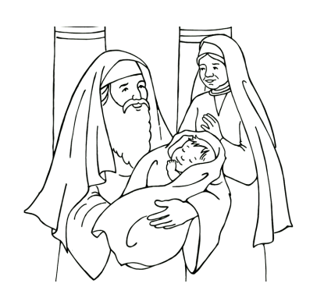  2 | 3
Mary and Joseph took baby _________ to the __________. They met a man called ____________ and a woman called ___________. | Simeon and Anna had been waiting for the baby Jesus.  They were ____________  to see him. | He said Jesus was  special and was going to be a saviour and a bright __________ shining in the world.
Some words which may help you,
light excited Simeon happy Jesus temple Anna

